**Ornament Ideas**

<https://www.happyfamilyart.com/art-lessons/mixed-media-art-lessons/recycled-sculptures/>

<https://www.instructables.com/Recycled-Fish-Wall-Art/>

<https://myonebeautifulthing.com/2019/02/09/fish-fry-recycled-art/>

**Marine Debris Ornament Ideas**

<https://blog.marinedebris.noaa.gov/washed-ashore-art-and-education>

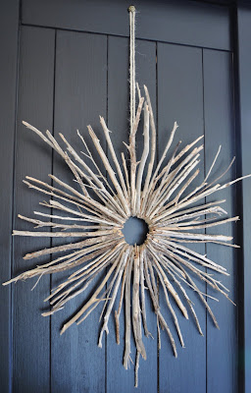

**Tree material Ornament Ideas**

<https://thepaintedhive.net/2010/08/starburst-twig-wreath/>

<http://www.ashbeedesign.com/2012/08/diy-variations-on-wood-slice-flowers.html>

<https://gardentherapy.ca/twiggy-gnomes/>

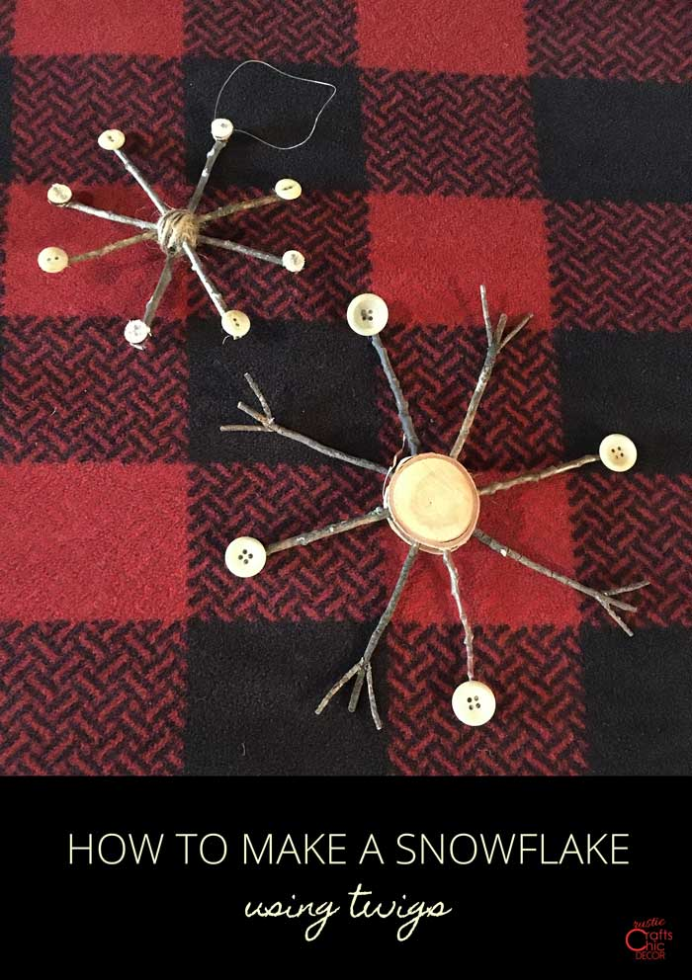

<https://gardentherapy.ca/twiggy-gnomes/>

<https://wonderfuldiy.com/wonderful-diy-rustic-twig-snowflakes/>

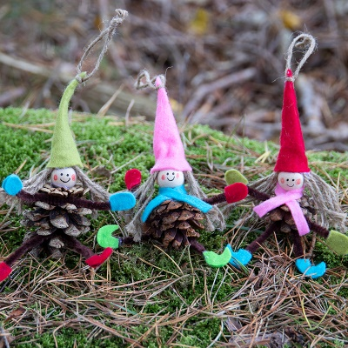<https://www.clubcreo.com/en/diy-for-adults-and-children/8-ideas-for-christmas-pine-cone-crafts/>

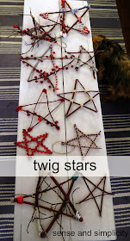Twig stars:

[http://gracie-senseandsimplicity.blogspot.com/2013/11/christmas-craft-party.html?m=1](https://gcc02.safelinks.protection.outlook.com/?url=http%3A%2F%2Fgracie-senseandsimplicity.blogspot.com%2F2013%2F11%2Fchristmas-craft-party.html%3Fm%3D1&data=05%7C02%7Cannette.heckart%40usda.gov%7C51f7a3c894254491c88308dc13082c77%7Ced5b36e701ee4ebc867ee03cfa0d4697%7C1%7C0%7C638406173083959583%7CUnknown%7CTWFpbGZsb3d8eyJWIjoiMC4wLjAwMDAiLCJQIjoiV2luMzIiLCJBTiI6Ik1haWwiLCJXVCI6Mn0%3D%7C3000%7C%7C%7C&sdata=Uo3lvAKyk%2Bch5NLzHEohwPfFDxdc2SJT%2BVOVc3sGNNk%3D&reserved=0)

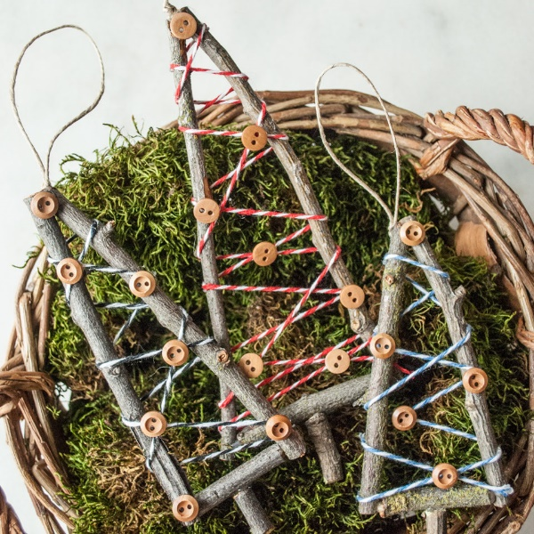

Rustic tree ornament

[http://cottagechroniclesblog.com/rustic-little-tree-ornament-handmade-christmas/](https://gcc02.safelinks.protection.outlook.com/?url=http%3A%2F%2Fcottagechroniclesblog.com%2Frustic-little-tree-ornament-handmade-christmas%2F&data=05%7C02%7Cannette.heckart%40usda.gov%7C51f7a3c894254491c88308dc13082c77%7Ced5b36e701ee4ebc867ee03cfa0d4697%7C1%7C0%7C638406173083959583%7CUnknown%7CTWFpbGZsb3d8eyJWIjoiMC4wLjAwMDAiLCJQIjoiV2luMzIiLCJBTiI6Ik1haWwiLCJXVCI6Mn0%3D%7C3000%7C%7C%7C&sdata=MBw%2FqWf1glR%2BsNvs%2FY030z6vJ%2BhZxzzH7gF8B61GiSE%3D&reserved=0)

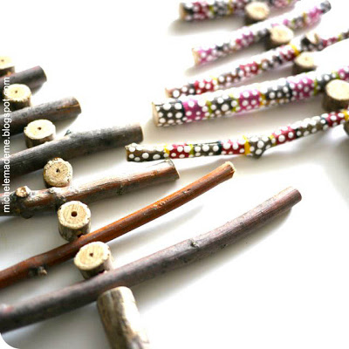

Twiggy Christmas trees <http://www.michelemademe.com/2011/07/twiggy-christmas-trees-in-july.html>

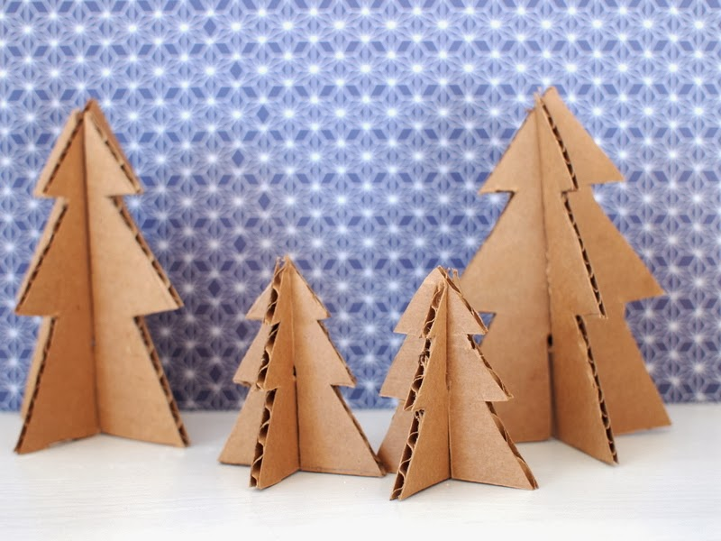

Cardboard tree <https://www.pinkstripeysocks.com/2013/12/make-mini-christmas-trees-from-pipe.html?m=1>

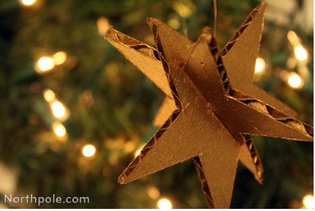Cardboard star

[http://www.northpole.com/craftcottage/twinkle-twinkle-cardboard-star](https://gcc02.safelinks.protection.outlook.com/?url=http%3A%2F%2Fwww.northpole.com%2Fcraftcottage%2Ftwinkle-twinkle-cardboard-star&data=05%7C02%7Cannette.heckart%40usda.gov%7C51f7a3c894254491c88308dc13082c77%7Ced5b36e701ee4ebc867ee03cfa0d4697%7C1%7C0%7C638406173083959583%7CUnknown%7CTWFpbGZsb3d8eyJWIjoiMC4wLjAwMDAiLCJQIjoiV2luMzIiLCJBTiI6Ik1haWwiLCJXVCI6Mn0%3D%7C3000%7C%7C%7C&sdata=AsJ0FkENxdrTq7oNn6%2F%2BYJja7JgLCs%2BQxDrsb8lAIwU%3D&reserved=0)

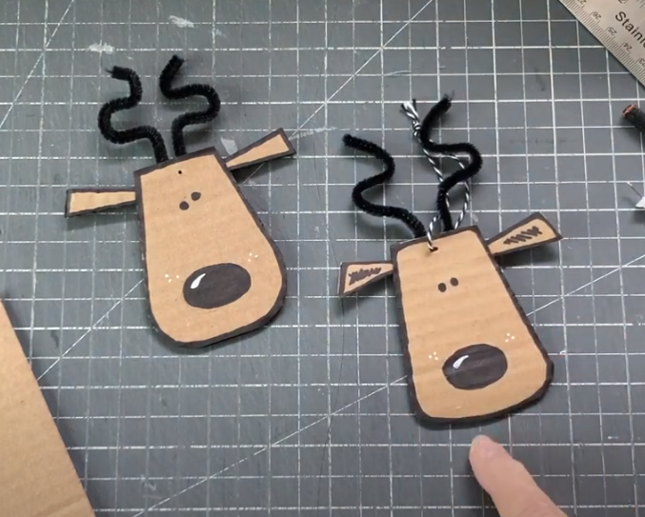Cardboard reindeer/moose

[https://m.youtube.com/watch?v=LgsVq5MxEcY](https://gcc02.safelinks.protection.outlook.com/?url=https%3A%2F%2Fm.youtube.com%2Fwatch%3Fv%3DLgsVq5MxEcY&data=05%7C02%7Cannette.heckart%40usda.gov%7C51f7a3c894254491c88308dc13082c77%7Ced5b36e701ee4ebc867ee03cfa0d4697%7C1%7C0%7C638406173084115867%7CUnknown%7CTWFpbGZsb3d8eyJWIjoiMC4wLjAwMDAiLCJQIjoiV2luMzIiLCJBTiI6Ik1haWwiLCJXVCI6Mn0%3D%7C3000%7C%7C%7C&sdata=qAHbAncu1%2BaMS%2FuzRFO9ZltYpO4RphXLymXHD80xflg%3D&reserved=0)

[https://m.youtube.com/watch?v=YEw7PF-CVNE&t=175s](https://gcc02.safelinks.protection.outlook.com/?url=https%3A%2F%2Fm.youtube.com%2Fwatch%3Fv%3DYEw7PF-CVNE%26t%3D175s&data=05%7C02%7Cannette.heckart%40usda.gov%7C51f7a3c894254491c88308dc13082c77%7Ced5b36e701ee4ebc867ee03cfa0d4697%7C1%7C0%7C638406173084115867%7CUnknown%7CTWFpbGZsb3d8eyJWIjoiMC4wLjAwMDAiLCJQIjoiV2luMzIiLCJBTiI6Ik1haWwiLCJXVCI6Mn0%3D%7C3000%7C%7C%7C&sdata=C3sxLuNkI7aYbWfgqrn0PKYlKDOXM8qtY7Qd6ITKexY%3D&reserved=0)

<https://makeetc.com/blogs/mixed-media-and-papercraft/tin-roof-houses-christmas-craft-project>

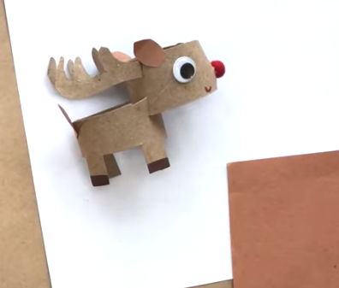

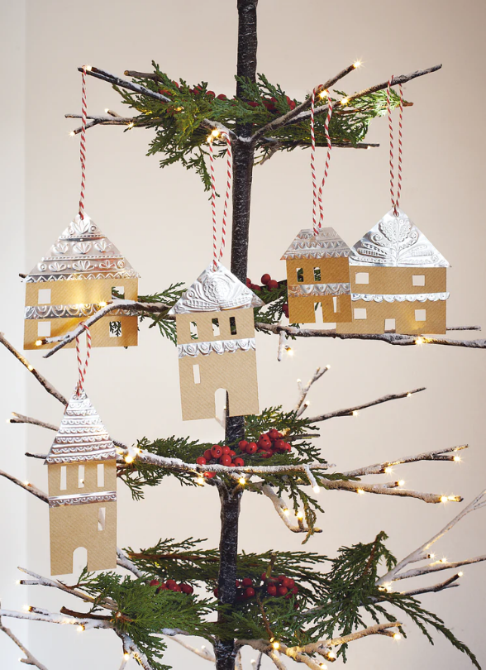

<https://makeetc.com/blogs/mixed-media-and-papercraft/origami-fir-tree>

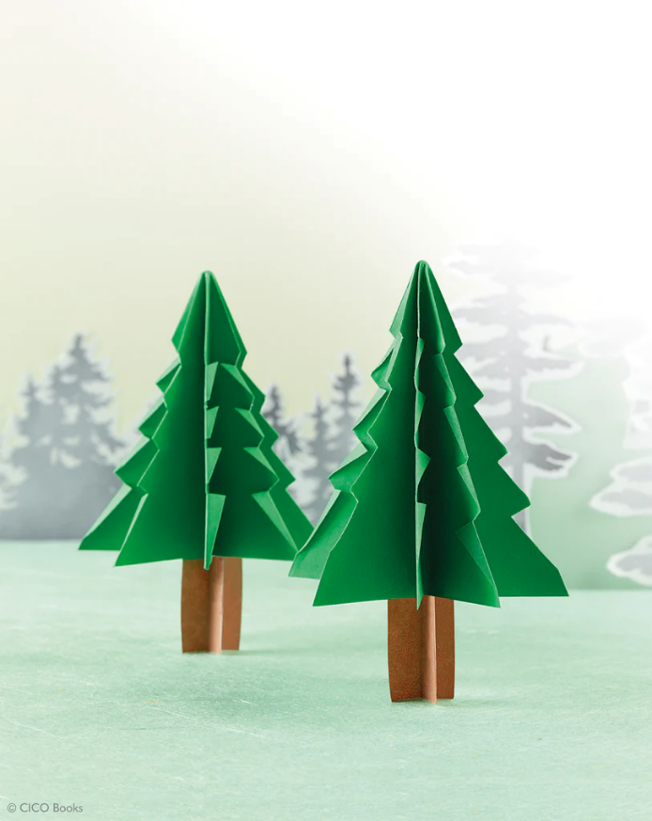

<https://makeetc.com/blogs/mixed-media-and-papercraft/honeycomb-bees>